Window setup

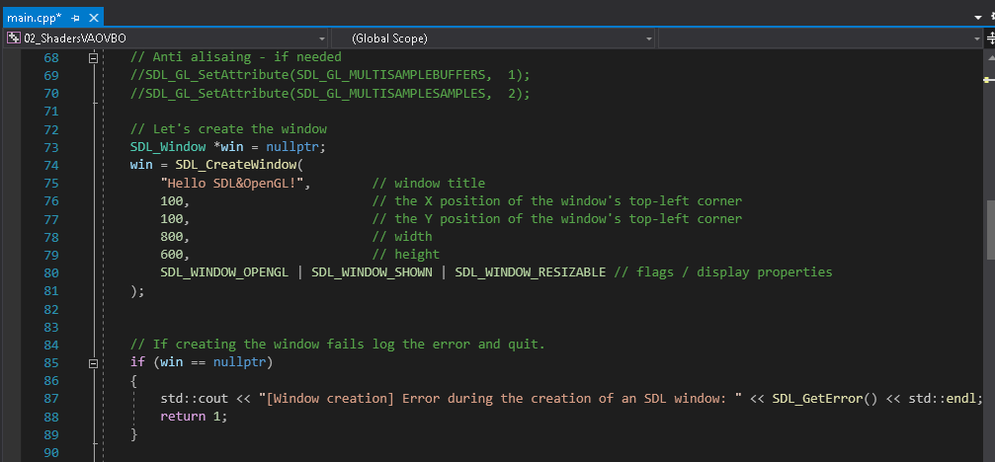

If we set 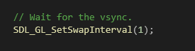 to 0, it will run much faster

:

We are drawing to a buffer that user cannot see . this swapps those buffers.